Pipedrive registration

1. First you need to create sandbox account. Go to: <https://pipedrive.readme.io/docs/developer-sandbox-account>

And click on the link “webform”.  
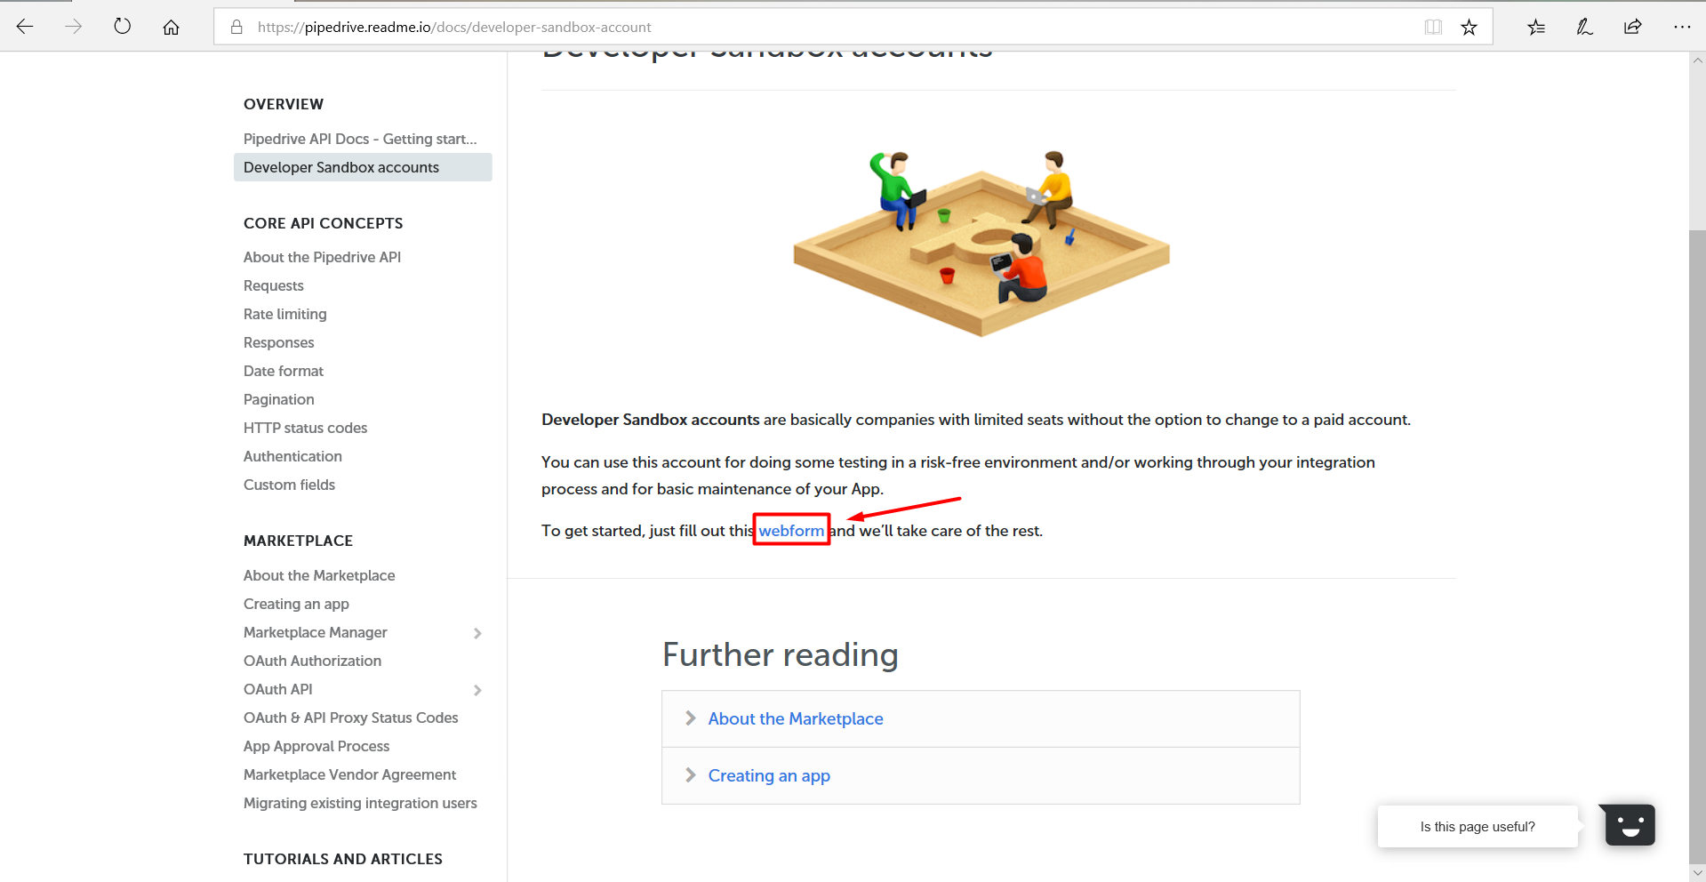

1. Fill the form and press “Submit” button.

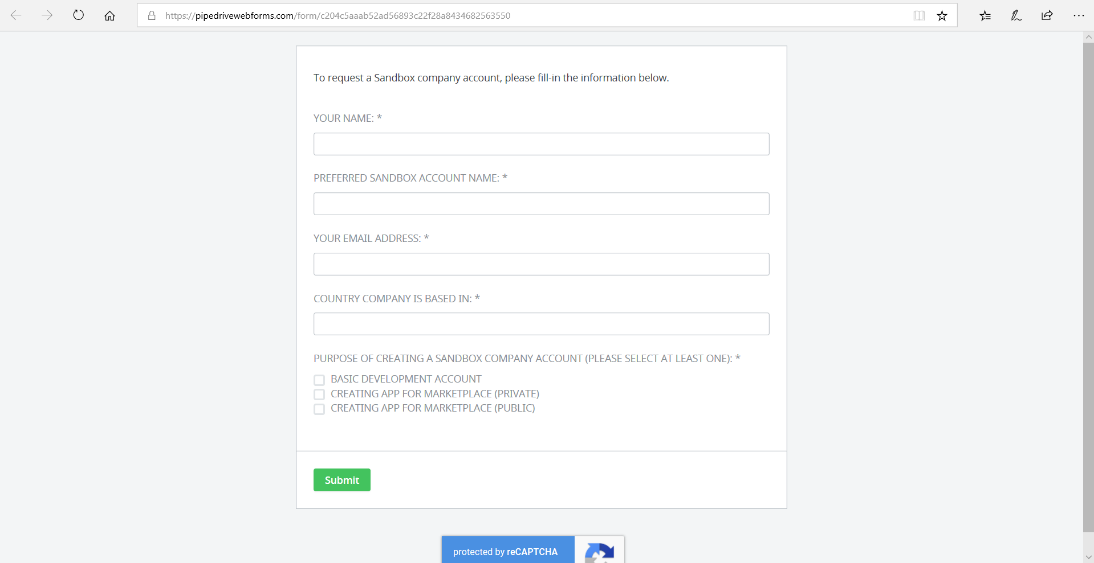

1. Wait for a message to your e-mail from Pipedrive team.  
   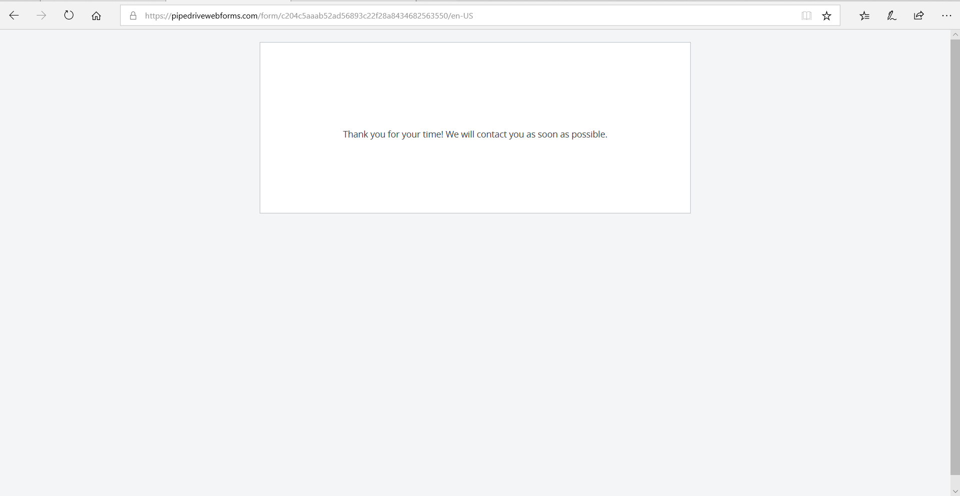

4. After activation click on profile in the right corner.  
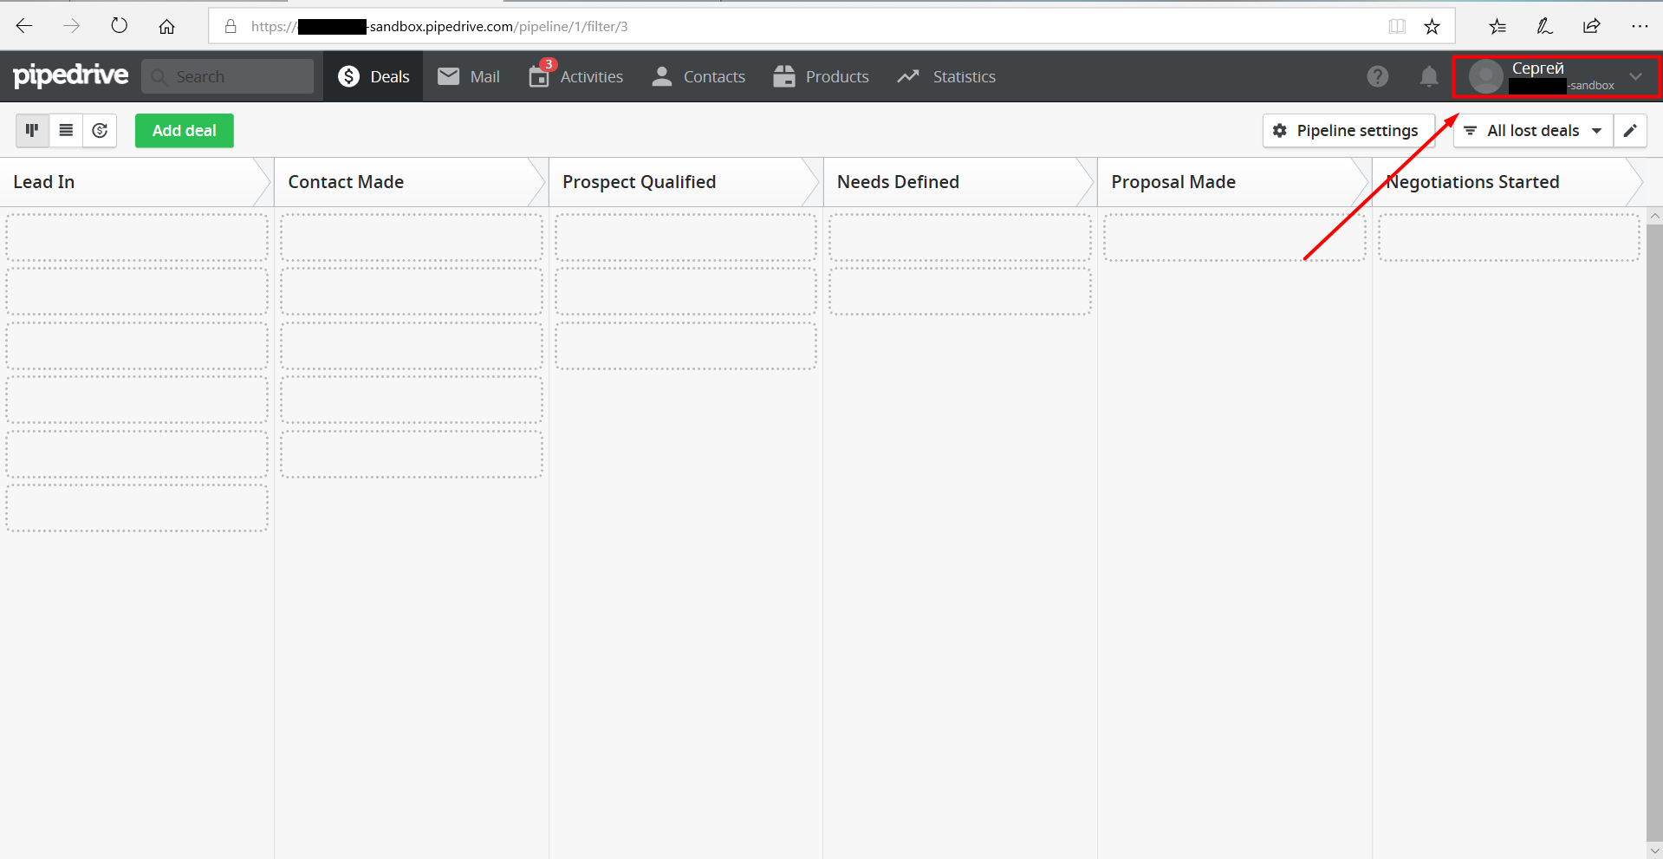

5. Click on “Settings”.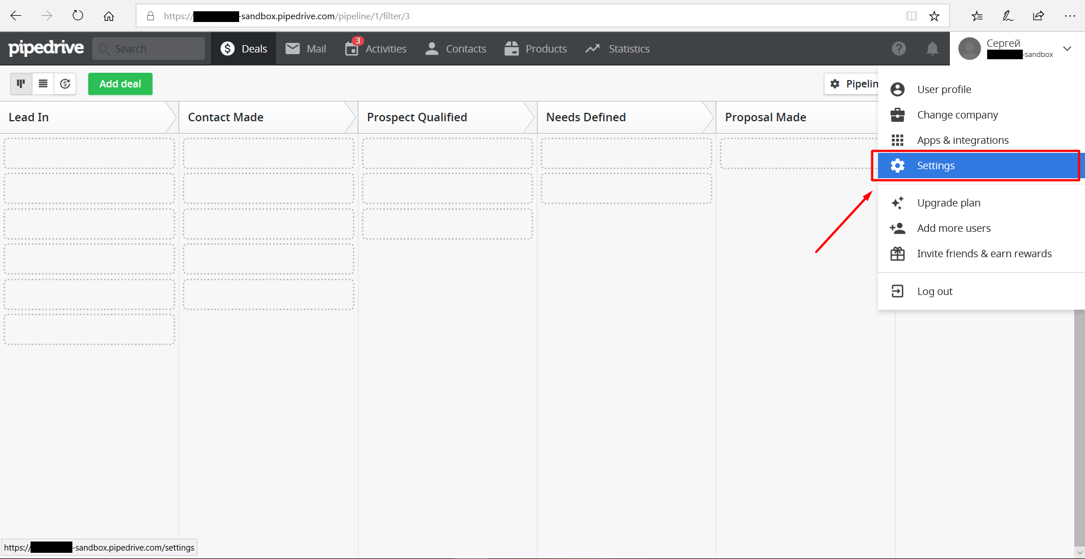

6. Click on “Marketplace Manager”.

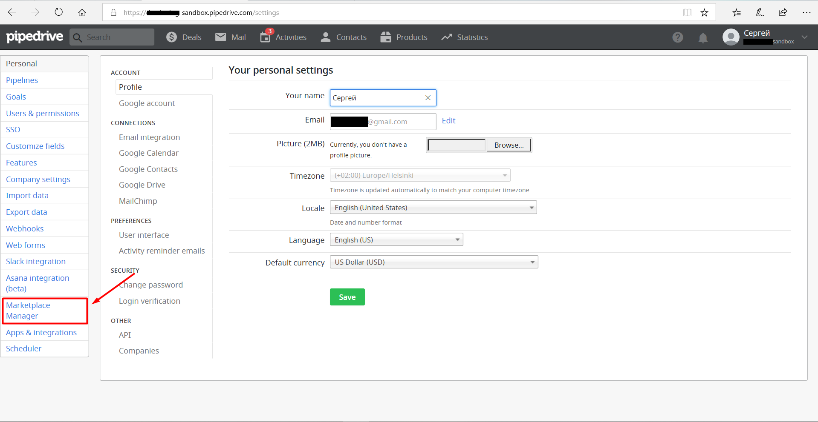

7. Click on the button “Create new app”.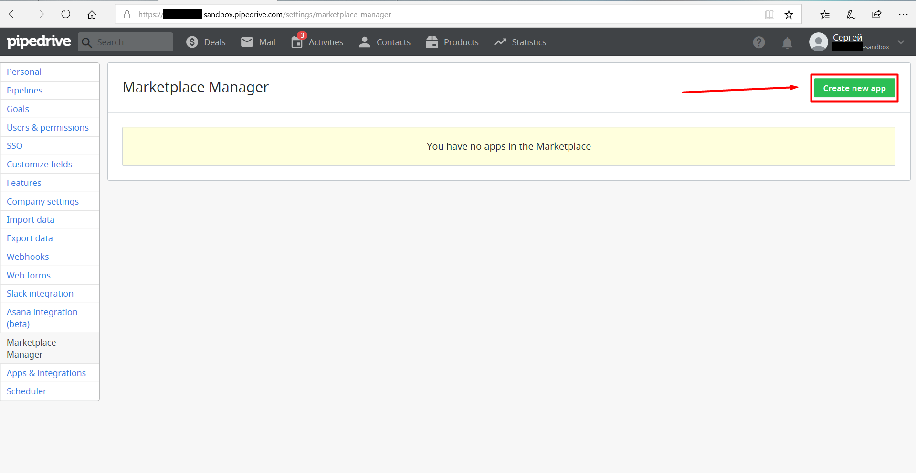

8. Fill the form and save app.

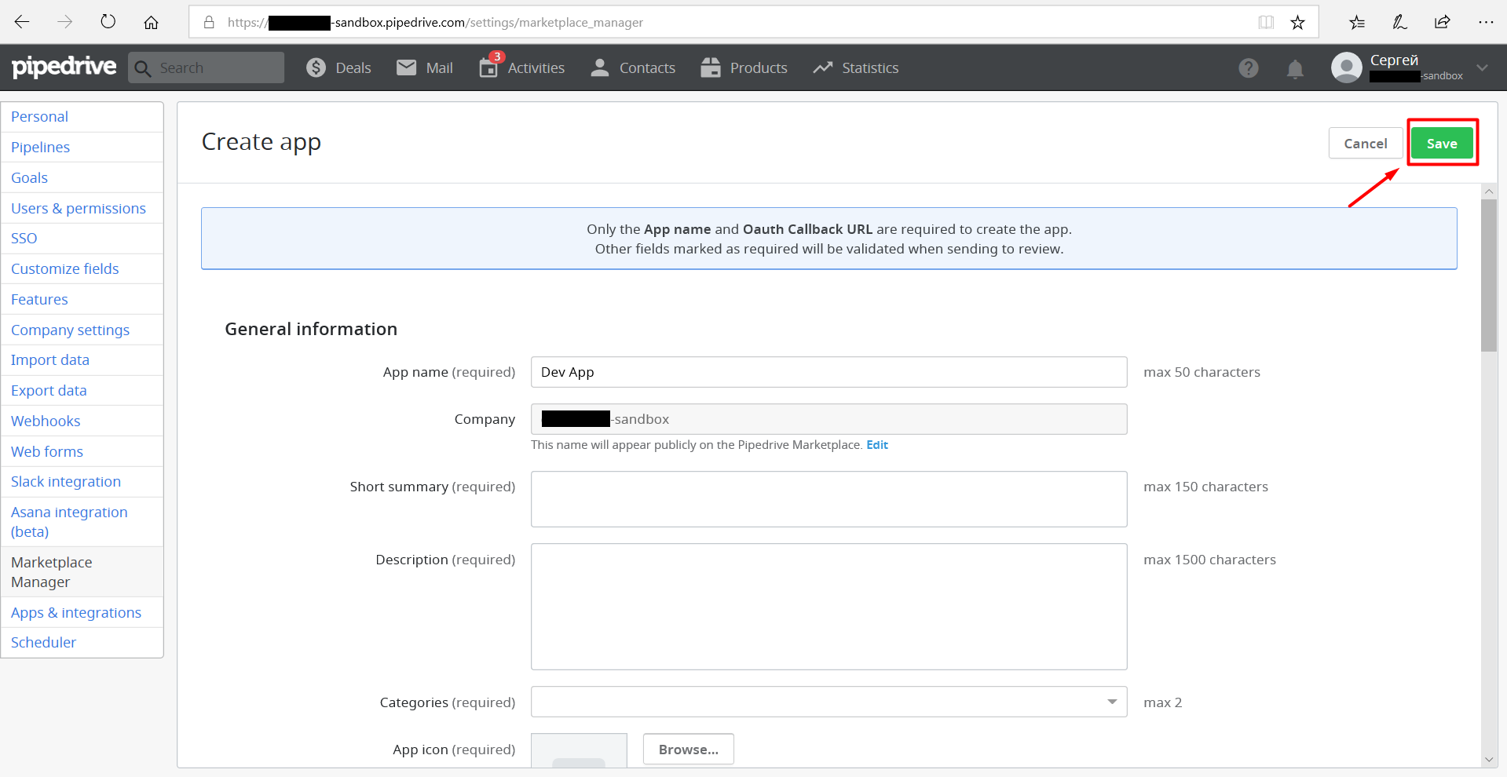

9. Open your created app and find below “OAuth & Access scopes”,

Copy CliendId and ClientSecret to your app.